The Calculation of the Pump flow rate Qp (m3/s)

The Qp for the case 1 or calculation group 1 is the volume flow rate of the suspension at the moment we reach our final cake height hc. (the case 1 is Dp=const, that is what we have now, but as we discussed we will have another 3 calculation groups: Qp=const/Qp=const and after Qp=const Dp=const/ Qp a definite function of Dp)

The Qp=Qsus,d (Qsus,d= dVsus/dt). The letter “d” means differential. Until now we calculate only average values. For example we calculate Qsus=Vsus/tf, or Qf=Vf/tf BUT we don’t calculate the differential values. That means for the following parameters we need to calculate and also display differential values because these values are also very important. Having these differential parameters then we have a complete set of all parameters we want to calculate and display. ONE SUCH DIFFERENTIAL PARAMETER IS Qp (what we want to display but we want to have it also as input in the other calculation groups. For this first calculation group this parameter should be always calculated like all other differential parameters, which I will list below).

Cake height hc

Until now we display only the cake height hc but we should add the following 2 parameters which will be only calculated:

hc/tf average cake height rate
dhc/dt differential cake height rate

Filtrate Mf, Vf

Until now we have the following parameters related to the filtrate:

Mf, Vf, mf, vf, Qmf, Qf, qmf, qf

Mf, Vf, mf, vf should belong to the hc-group (that means we should enable the input of these parameters. Only in Design modus (A is not given) the Mf, Vf should be calculated always)

Qmf,Qf should belong to the group of Qsus and in case of Design we should enable the input of these parameters.
qmf, qf should be always calculated.

For the filtrate we need also differential parameters:
Qmf,d
Qf,d
qmf,d
qf,d
Suspension Msus, Vsus

Until now we have the following parameters related to the Suspension:

Msus, Vsus, msus, vsus, Qmsus, Qsus, qmsus, qsus

Msus, Vsus, msus, vsus should belong to the hc-group (that means we should enable the input of these parameters. Only in Design modus (A is not given) the Msus, Vsus should be calculated always)

Qmsus,Qsus should belong to the group of Qs and in case of Design we should enable the input of these parameters.

qmsus, qsus should be always calculated.

For the Suspension we need also differential parameters:
Qmsus,d
Qsus,d This parameter is our Qp
qmsus,d
qsus,d

Solids Ms, Vs

Until now we have the following parameters related to the Solids:

Ms, Vs, ms, vs, Qms, Qs, qms, qs

Ms, Vs, ms, vs should belong to the hc-group (that means we should enable the input of these parameters. Only in Design modus (A is not given) the Ms, Vs should be calculated always)

Qms,Qs should belong to the group of Qsus and in case of Design we should enable the input of these parameters.
qms, qs should be always calculated.

For the Solids we need also differential parameters:
Qms,d
Qs,d
qms,d
qs,d
Filter Cake Mc, Vc

Until now we have the following parameters related to the filter cake:

Mc, Vc, mc, vc, Qmc, Qc, qmc, qc (Please notice that I changed the index for the cake height parameters: instead of “cake” I use just “c”

Mc, Vc, mc, vc should belong to the hc-group (that means we should enable the input of these parameters. Only in Design modus (A is not given) the Mc, Vc should be calculated always)

Qmc,Qc should belong to the group of Qsus and in case of Design we should enable the input of these parameters.
qmc, qc should be always calculated.

For the filter cake we need also differential parameters:
Qmc,d
Qc,d
qmc,d
qc,d

Equations for the differential parameters

The cake height hc

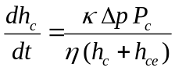

Filtrate Mf, Vf

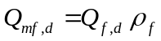
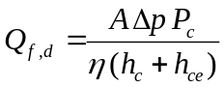
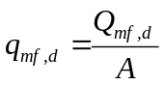
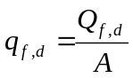

Suspension Msus, Vsus

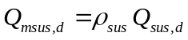
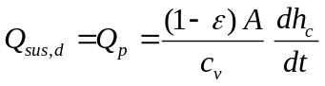 (That is the equation for the calculation of the pump flow rate Q_{p})

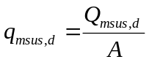
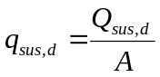

Solids Ms, Vs

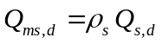
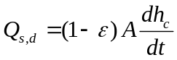
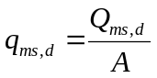
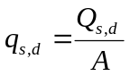

Filter Cake Mc, Vc

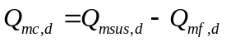
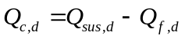
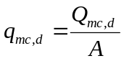
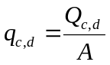

Listing of all Parameters

Number | Parameter | Name | Unit (SI) | Default Unit | Input/calculated
1 | A | Filter area | m2 | m2 | i/c
2 | Dp | Pressure Difference | Pa | bar | i/c
3 | tf | Filtartion time | s | s | i/c
4 | sf | Specific filtration time | -- | % | i/c
5 | tr | Rest time | s | s | i/c
6 | tc | Cycle time | s | s | i/c
7 | n | Cycle frequency | s-1 | min-1 | i/c
8 | hc | Cake height | m | mm | i/c
9 | hc/tf | Mean height rate | m/s | mm/min | c
10 | dhc/dt | Diff. height rate | m/s | mm/min | c
11 | Msus | Suspension Mass | kg | kg | i/c
12 | Vsus | Suspension volume | l | l | i/c
13 | msus | Specific susp mass | Kg/m2 | Kg/m2 | i/c
14 | vsus | Specific susp volume | m3/m2 | l/m2 | i/c
15 | Qmsus | Susp mass rate | Kg/s | Kg/h | i/c
16 | Qmsus,d | Diff susp mass rate | Kg/s | Kg/h | c
17 | Qsus | Susp volume rate | m3/s | l/h | i/c
18 | Qsus,d | Diff Susp volume rate | m3/s | l/h | i/c
19 | qmsus | Spec susp mass rate | Kg/(m2 s) | Kg/(m2 min) | c
20 | qmsus,d | Diff spec susp mass rate | Kg/(m2 s) | Kg/(m2 min) | c
21 | qsus | Spec susp volume rate | m3/(m2 s) | l/(m2 min) | c
22 | qsus,d | Diff Spec susp vol rate | m3/(m2 s) | l/(m2 min) | c
23 | Mf | Filtrate Mass | kg | kg | i/c
24 | Vf | Filtrate volume | l | l | i/c
25 | mf | Specific filtrate mass | Kg/m2 | Kg/m2 | i/c
26 | vf | Specific filtrate volume | m3/m2 | l/m2 | i/c
27 | Qmf | Filtrate mass rate | Kg/s | Kg/h | i/c
28 | Qmf,d | Diff filtrate mass rate | Kg/s | Kg/h | c
29 | Qf | Filtrate volume rate | m3/s | l/h | i/c
30 | Qf,d | Diff filtrate volume rate | m3/s | l/h | c
31 | qmf | Spec filtrate mass rate | Kg/(m2 s) | Kg/(m2 min) | c
32 | qmf,d | Diff spec filtr mass rate | Kg/(m2 s) | Kg/(m2 min) | c
33 | qf | Spec filtr volume rate | m3/(m2 s) | l/(m2 min) | c
34 | qf,d | Diff Spec filtr vol rate | m3/(m2 s) | l/(m2 min) | c
35 | Ms | Solids Mass | kg | kg | i/c
36 | Vs | Solids volume | l | l | i/c
37 | ms | Specific solids mass | Kg/m2 | Kg/m2 | i/c
38 | vs | Specific solids volume | m3/m2 | l/m2 | i/c
39 | Qms | Solids mass rate | Kg/s | Kg/h | i/c
40 | Qms,d | Diff solids mass rate | Kg/s | Kg/h | c
41 | Qs | Solids volume rate | m3/s | l/h | i/c
42 | Qs,d | Diff solids volume rate | m3/s | l/h | c
43 | qms | Spec solids mass rate | Kg/(m2 s) | Kg/(m2 min) | c
44 | qms,d | Diff spec solids mass rate | Kg/(m2 s) | Kg/(m2 min) | c
45 | qs | Spec solids volume rate | m3/(m2 s) | l/(m2 min) | c
46 | qs,d | Diff Spec solids vol rate | m3/(m2 s) | l/(m2 min) | c
47 | Mc | Cake Mass | kg | kg | i/c
48 | Vc | Cake volume | l | l | i/c
49 | mc | Specific cake mass | Kg/m2 | Kg/m2 | i/c
50 | vc | Specific cake volume | m3/m2 | l/m2 | i/c
51 | Qmc | cake mass rate | Kg/s | Kg/h | i/c
52 | Qmc,d | Diff cake mass rate | Kg/s | Kg/h | c
53 | Qc | Cake volume rate | m3/s | l/h | i/c
54 | Qc,d | Diff cake volume rate | m3/s | l/h | c
55 | qmc | Spec cake mass rate | Kg/(m2 s) | Kg/(m2 min) | c
56 | qmc,d | Diff spec cake mass rate | Kg/(m2 s) | Kg/(m2 min) | c
57 | qc | Spec cake volume rate | m3/(m2 s) | l/(m2 min) | c
58 | qc,d | Diff Spec cake vol rate | m3/(m2 s) | l/(m2 min) | c

